Table of Contents – Flatball Inertial Navigation System

Appendix – Prototypes 3

SN:202200001 3

SN:2024032202 6

SN:2024110603 18

# Appendix – Prototypes

## SN:202200001

#### SN:2022000001 – assembly

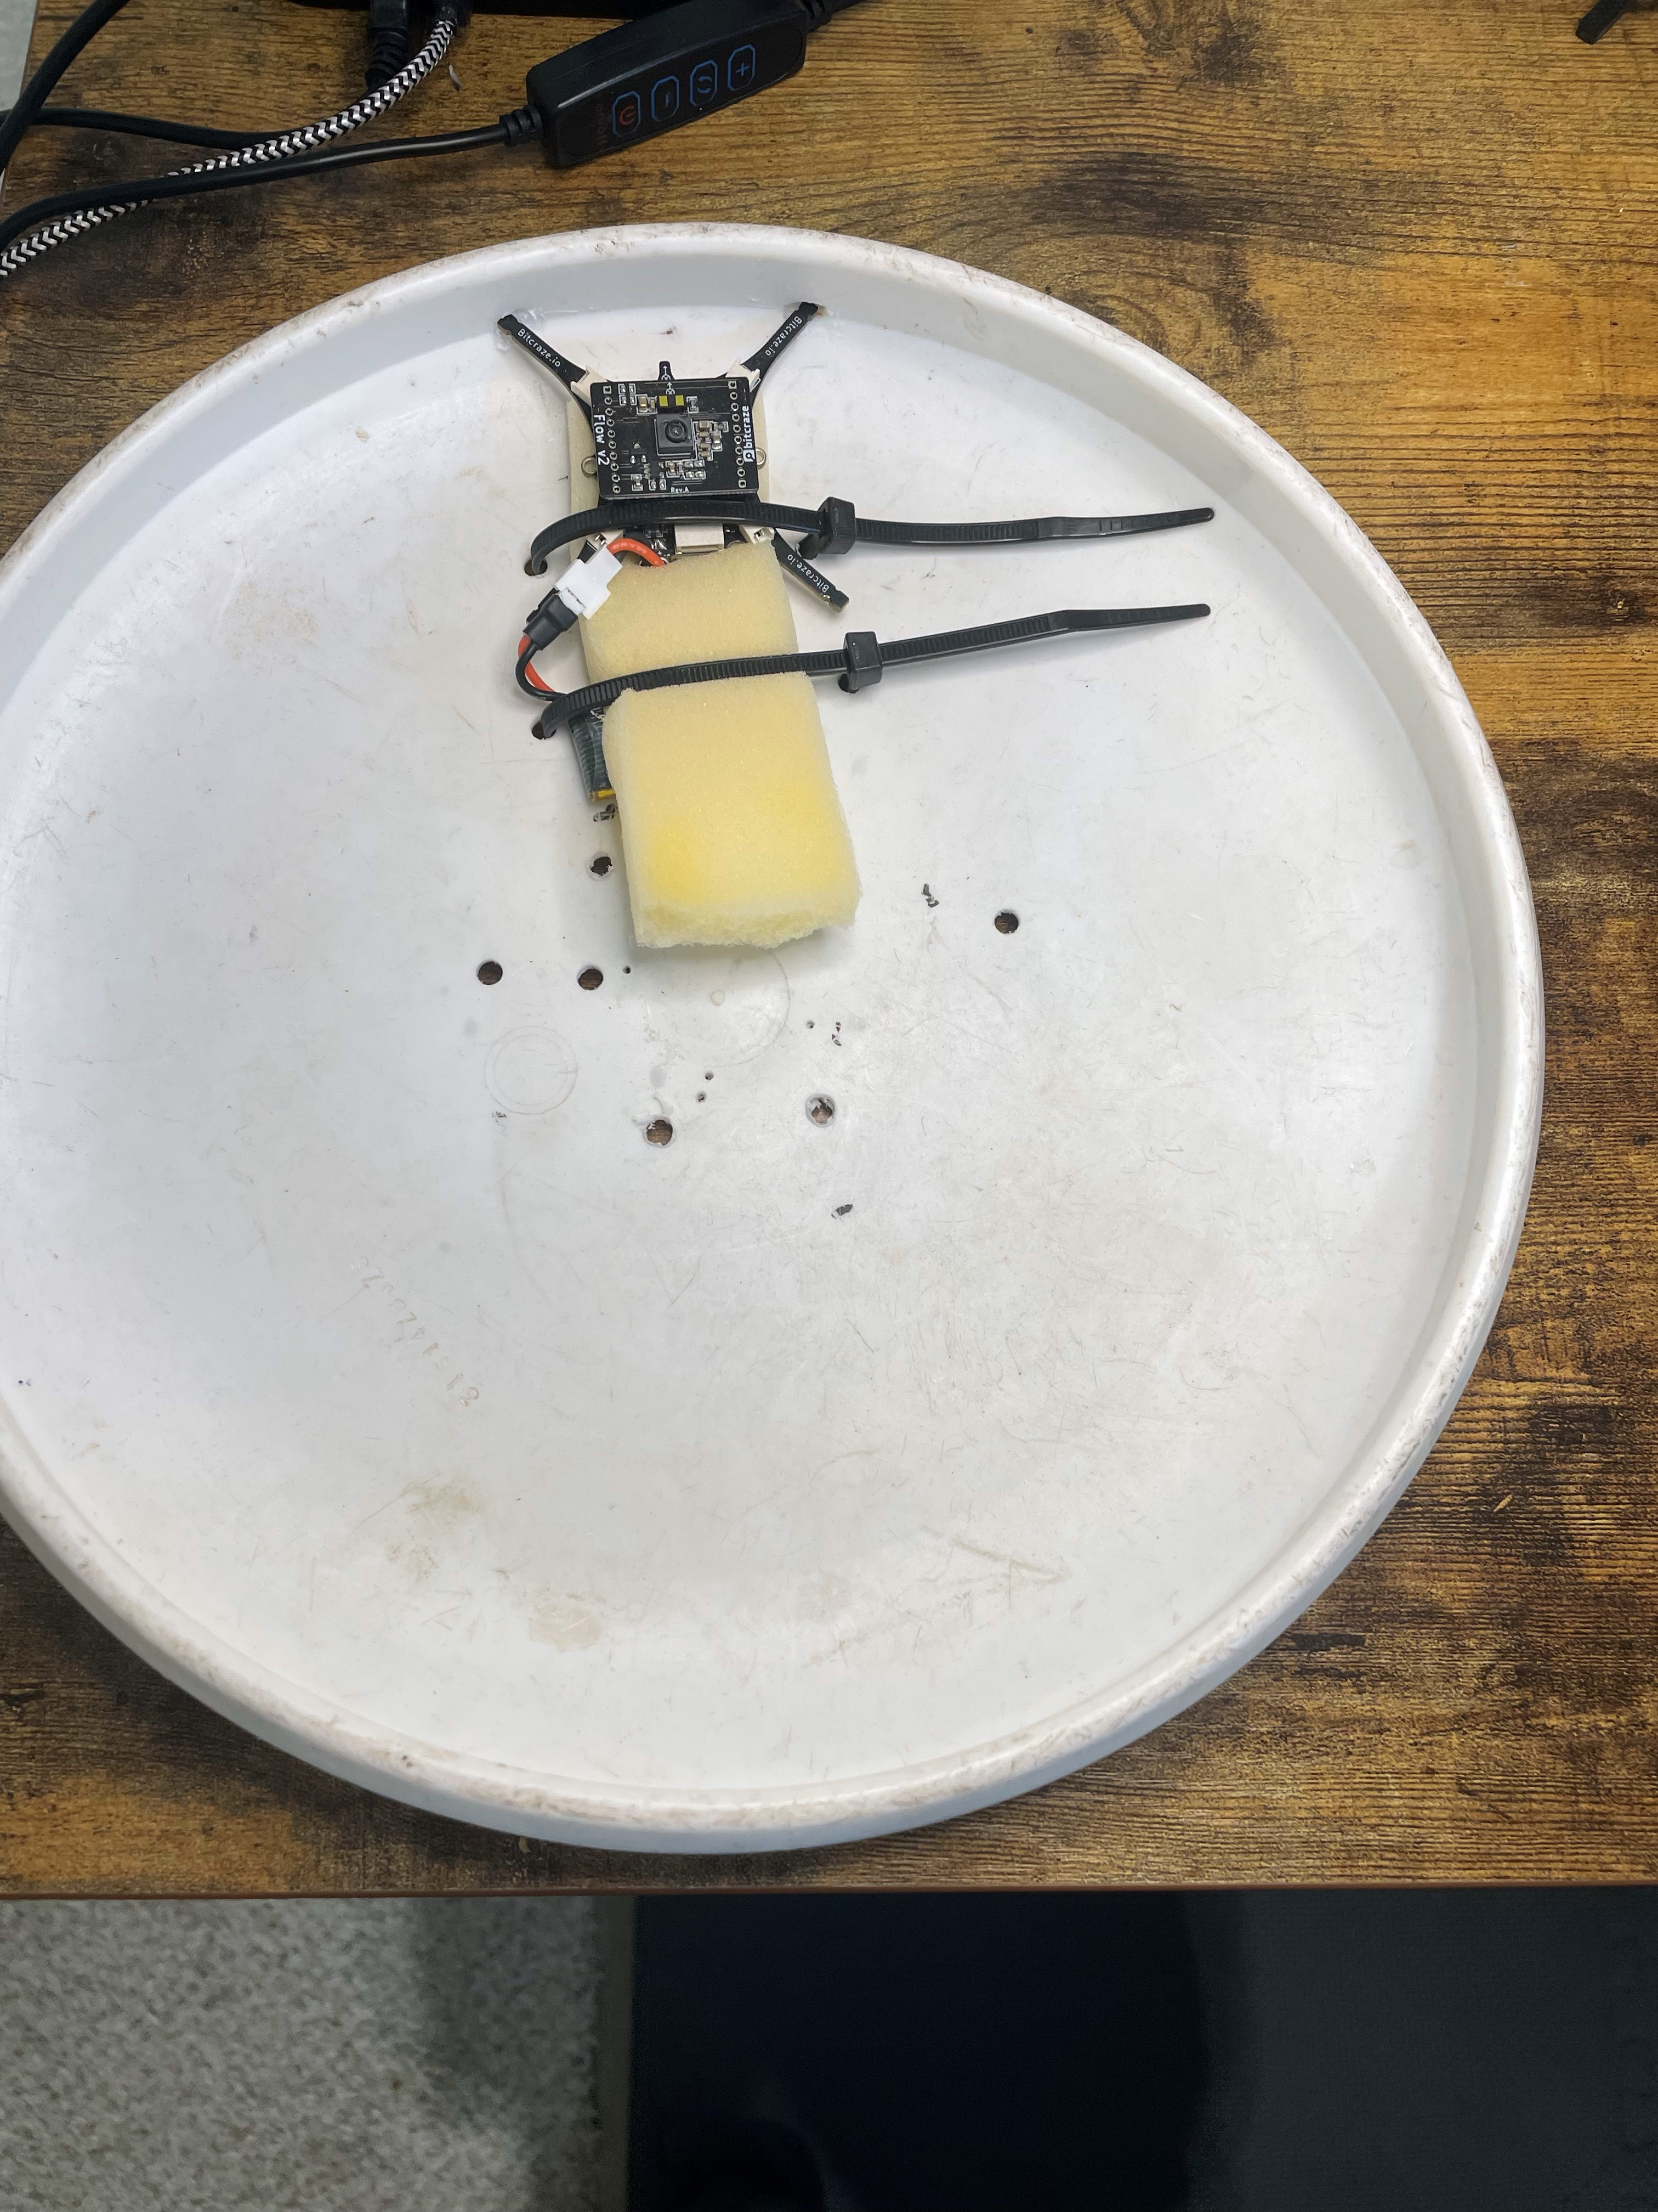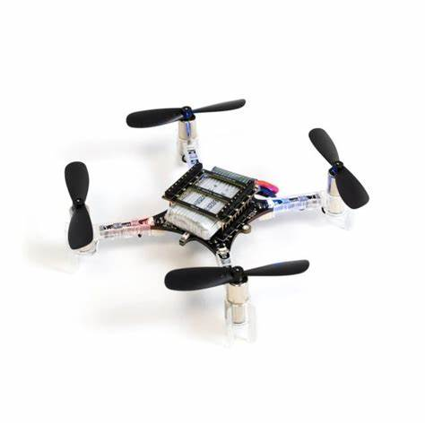

## SN:2024032202

#### SN: 2024032202– assembly

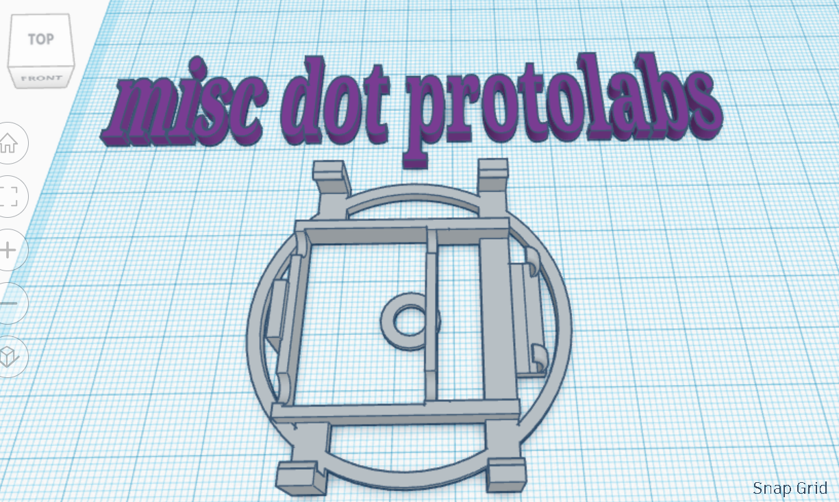

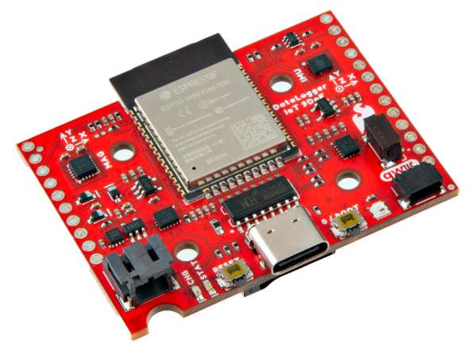

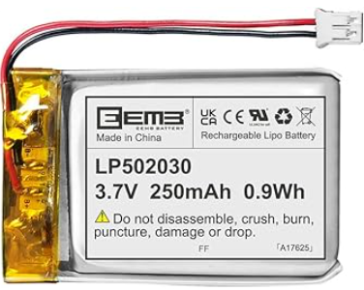

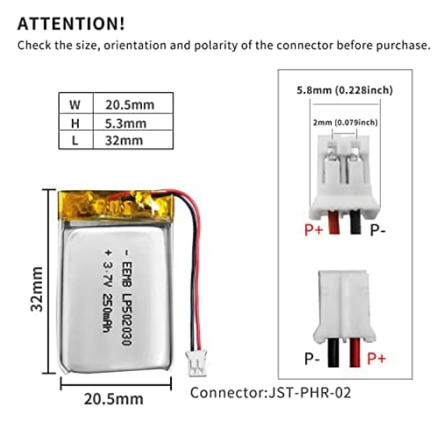

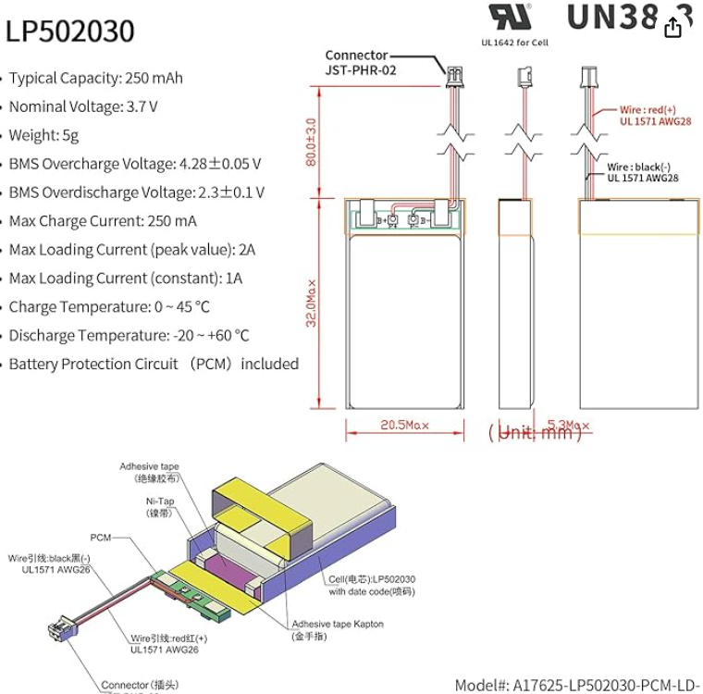

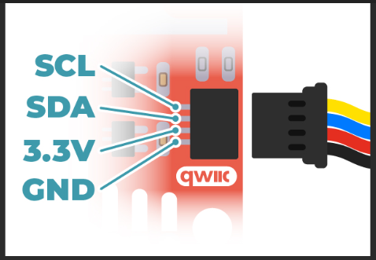

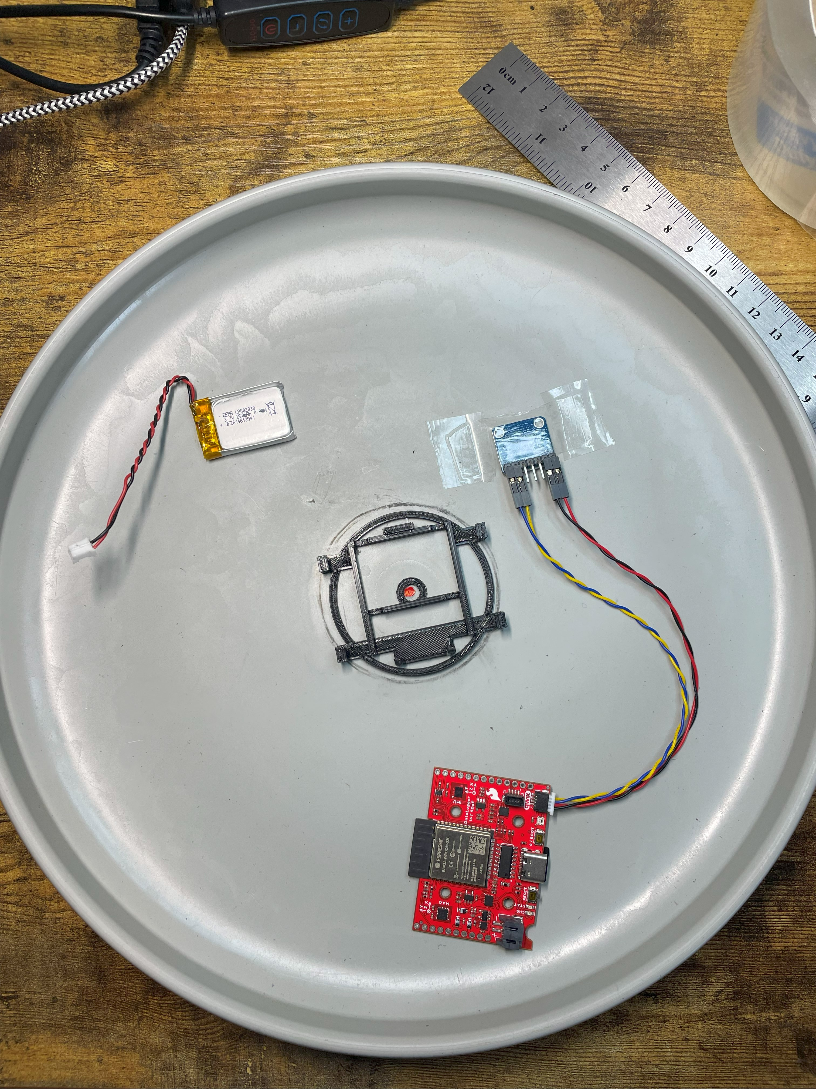

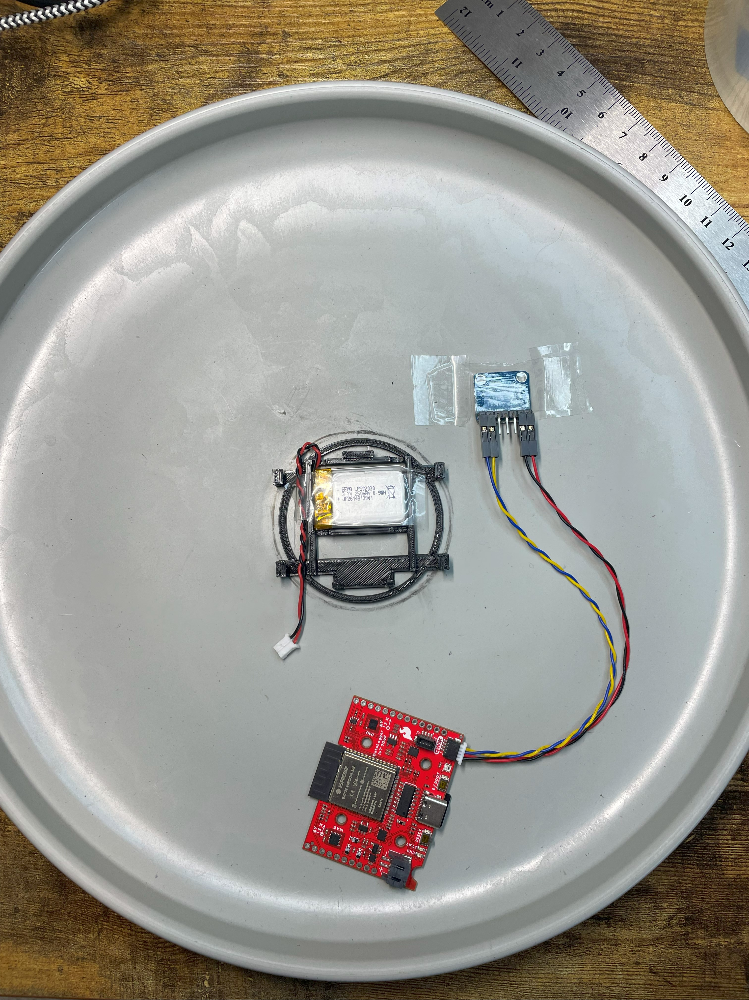

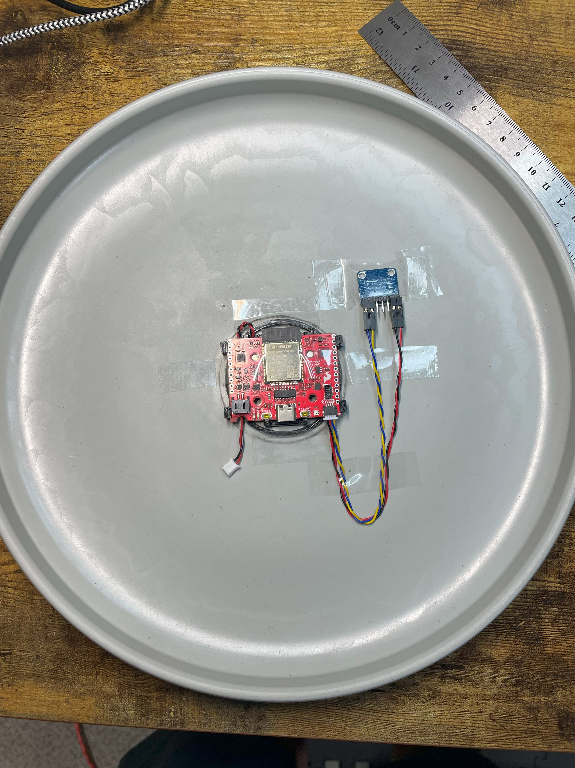

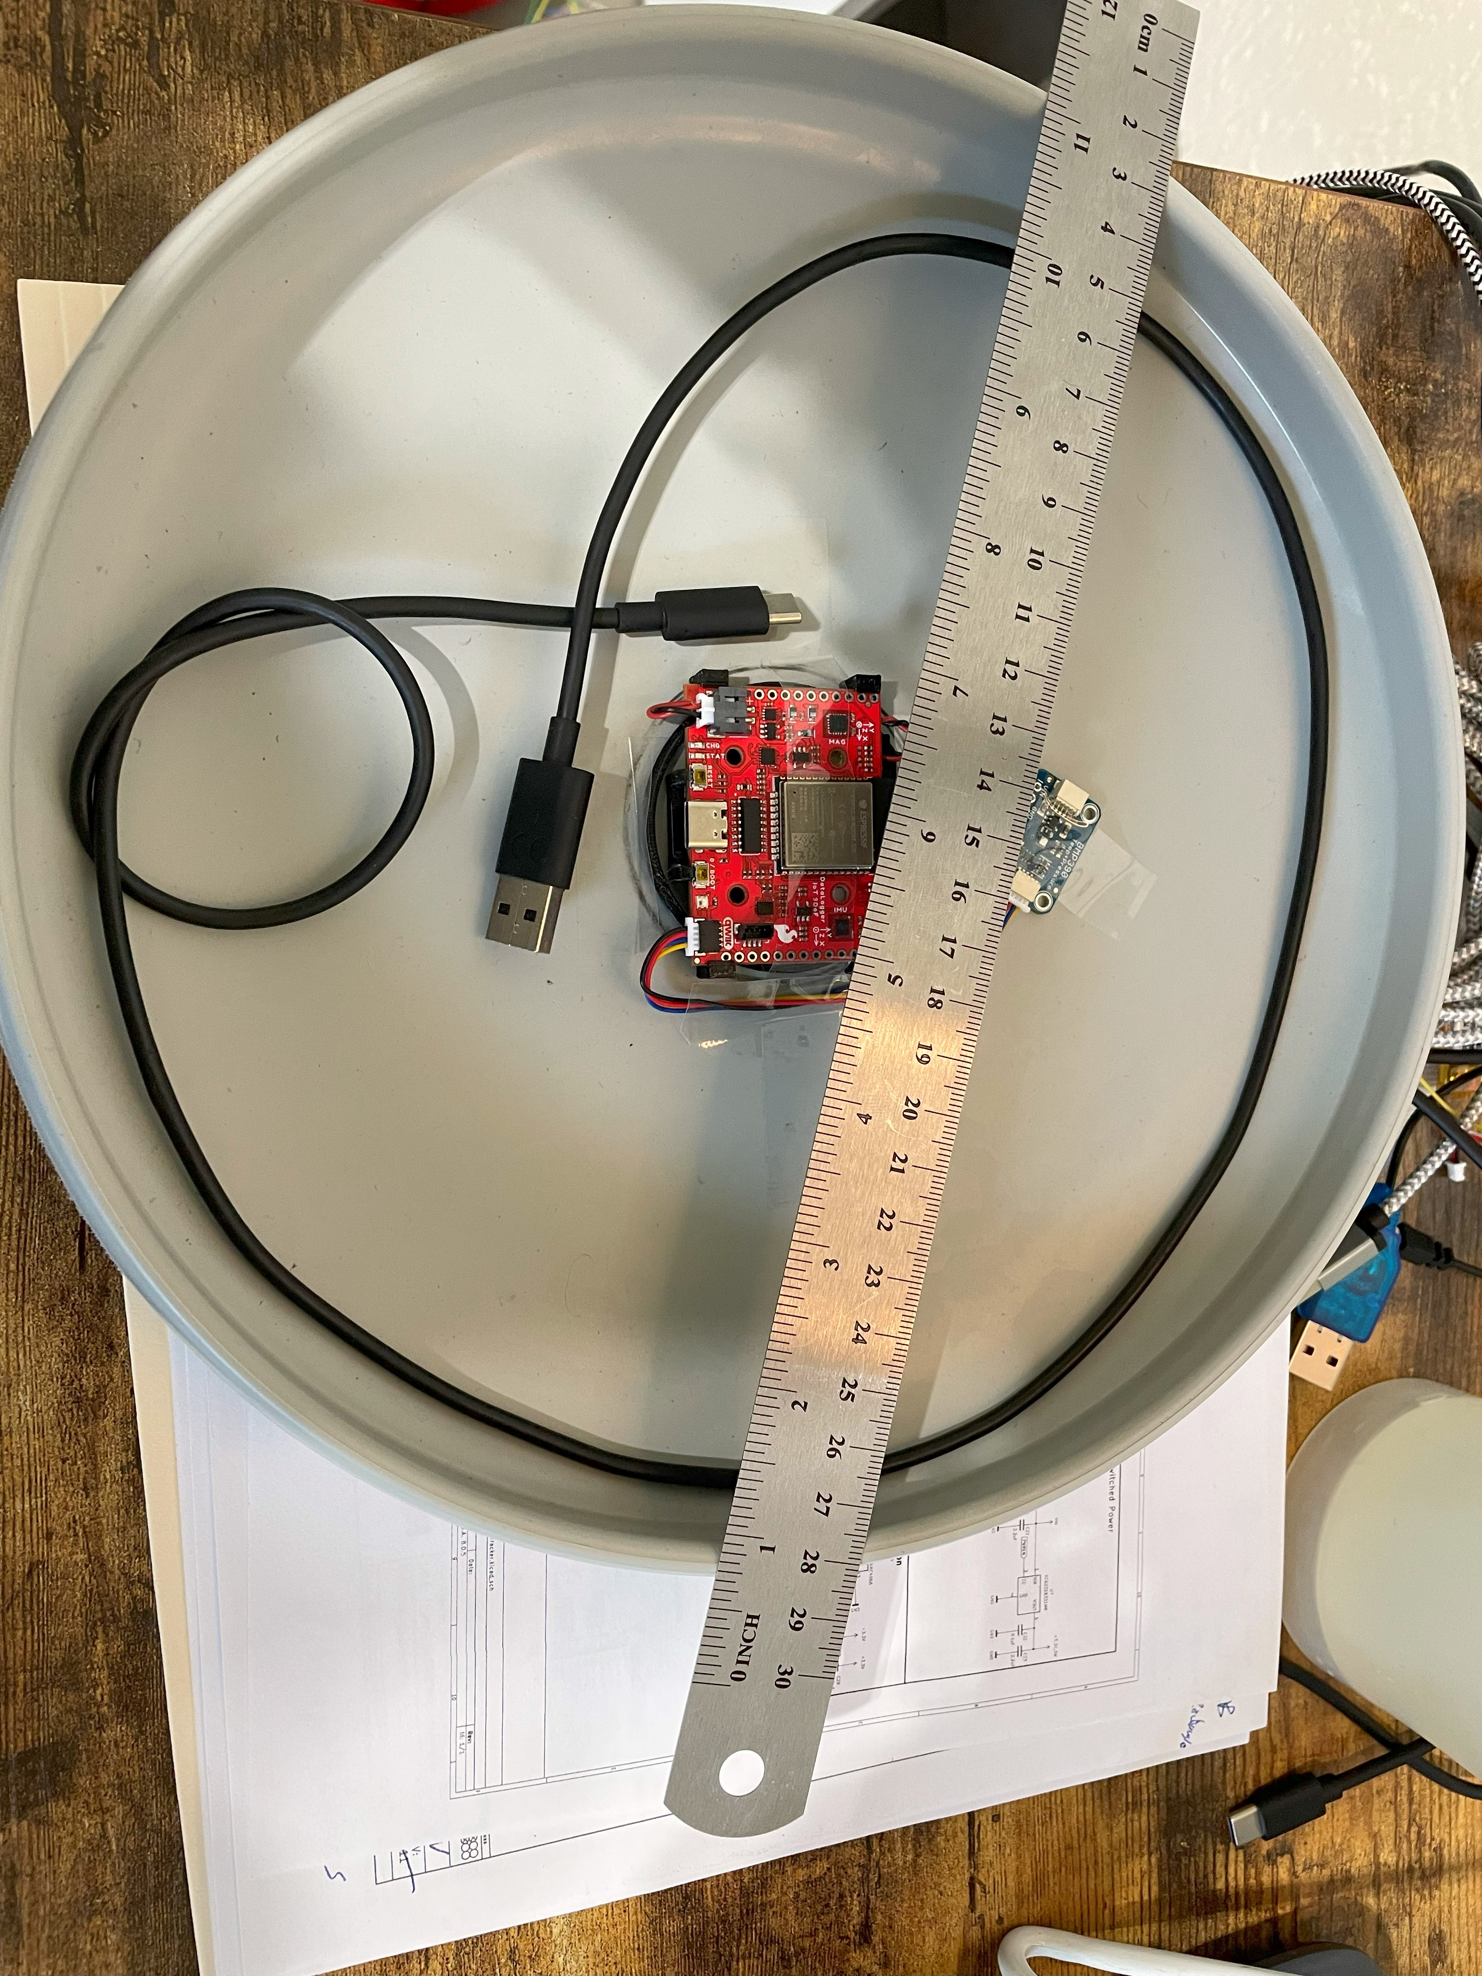

#### SN: 2024032202– surgery

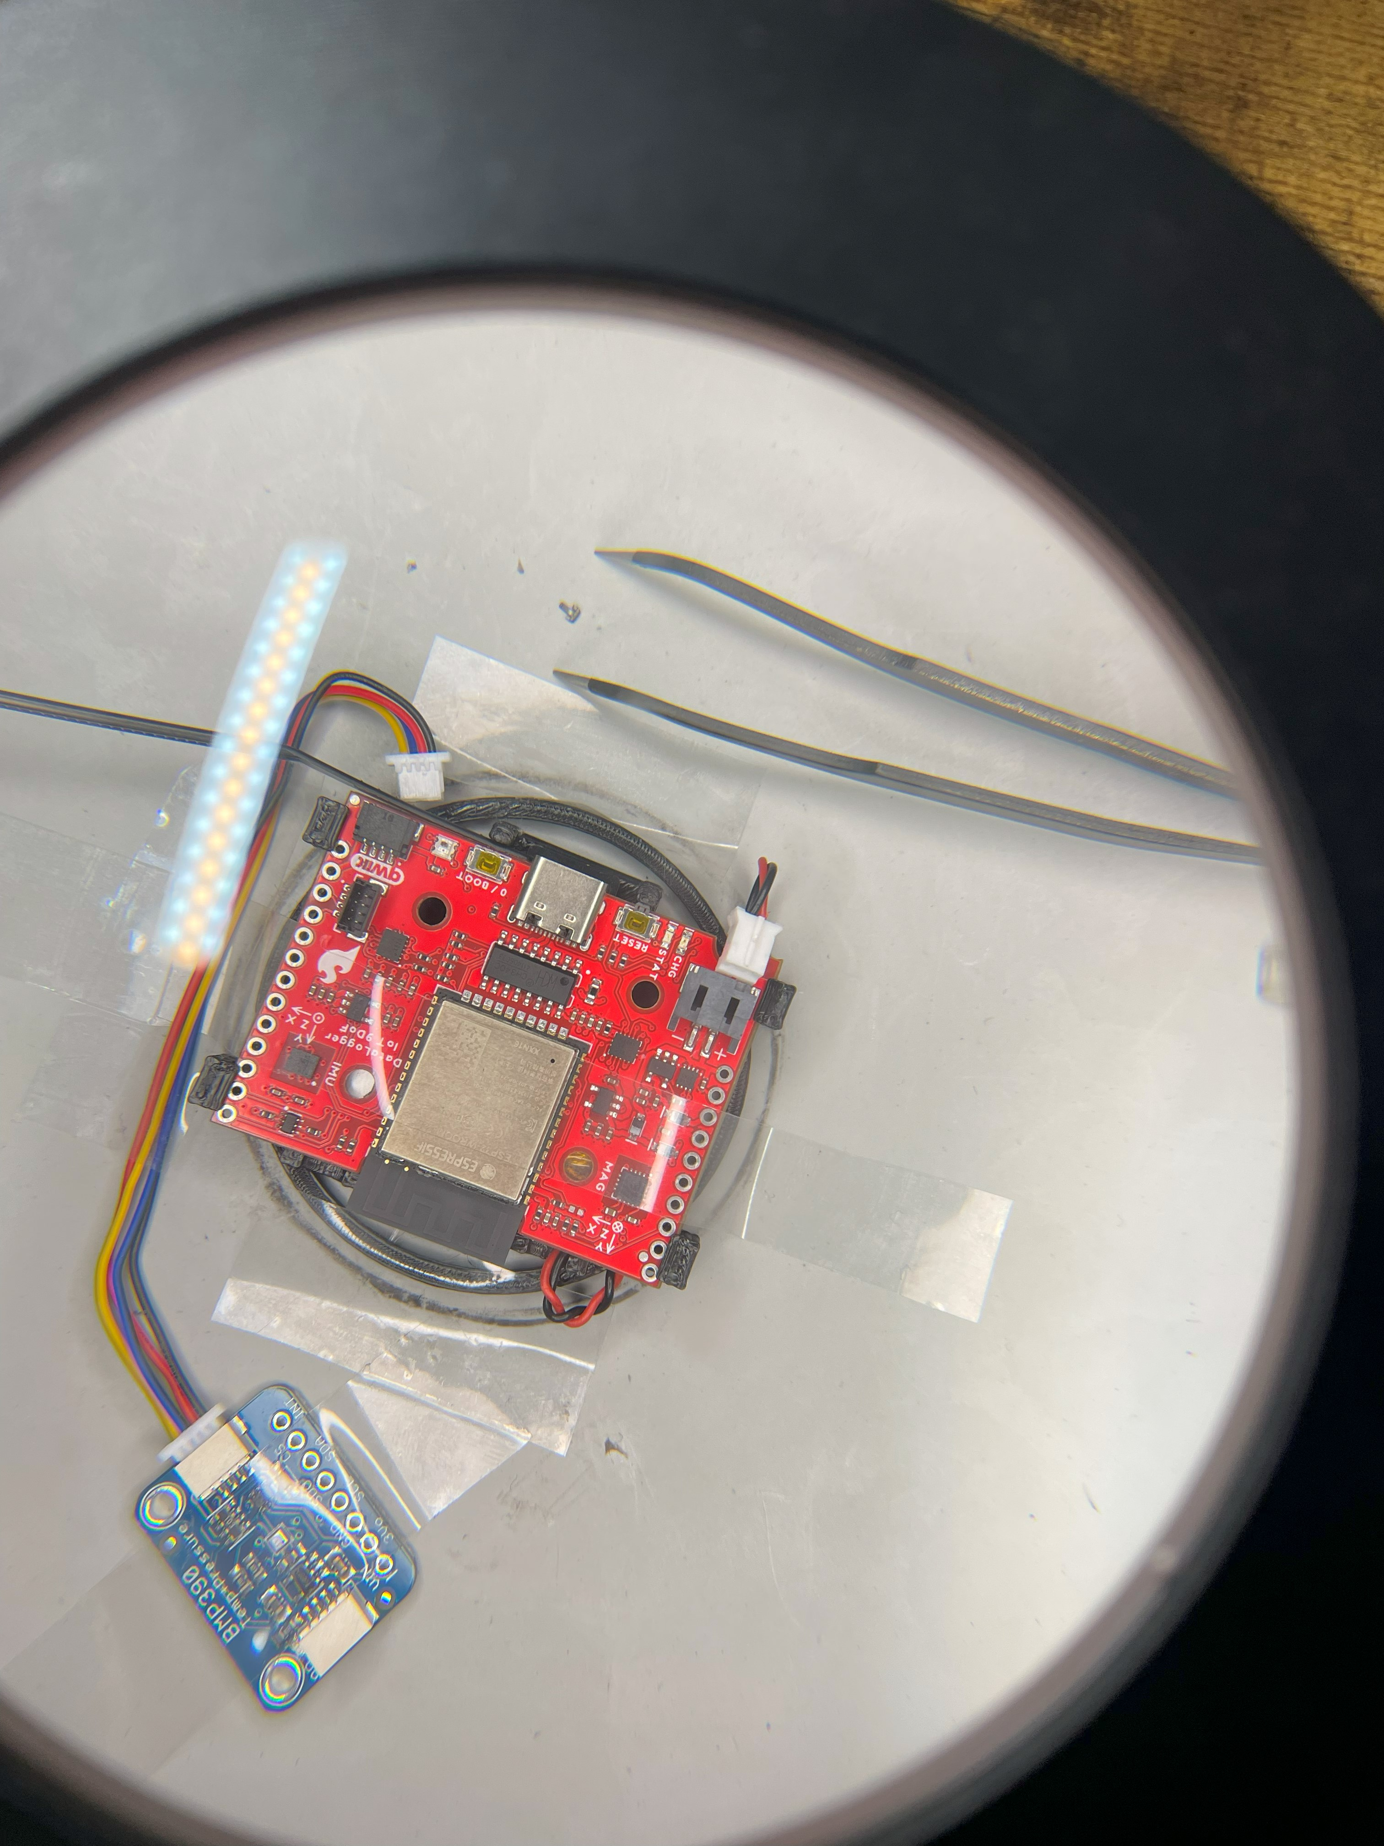

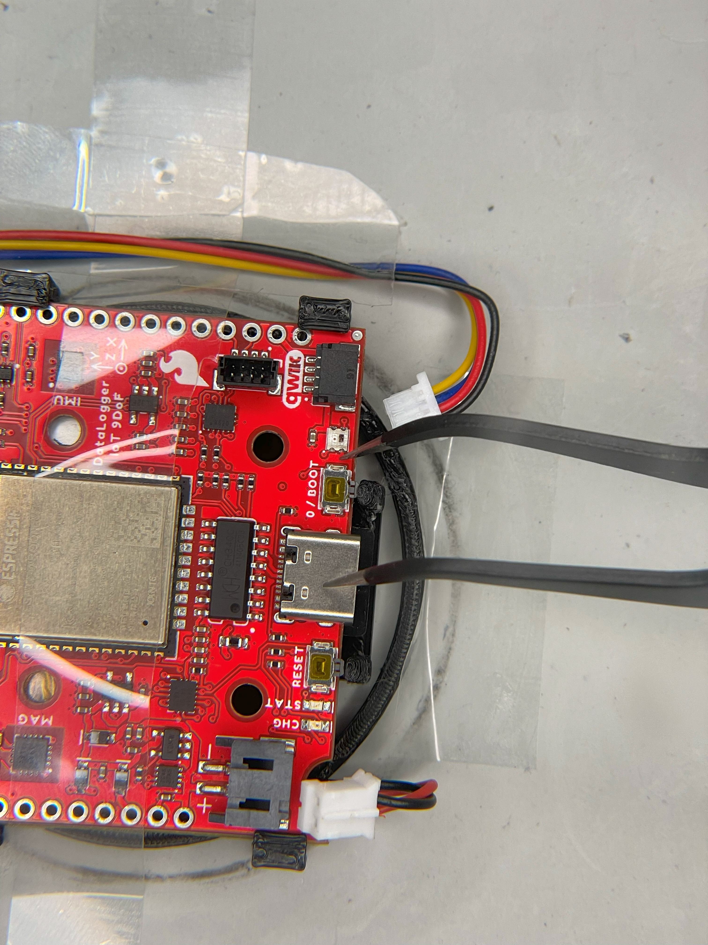

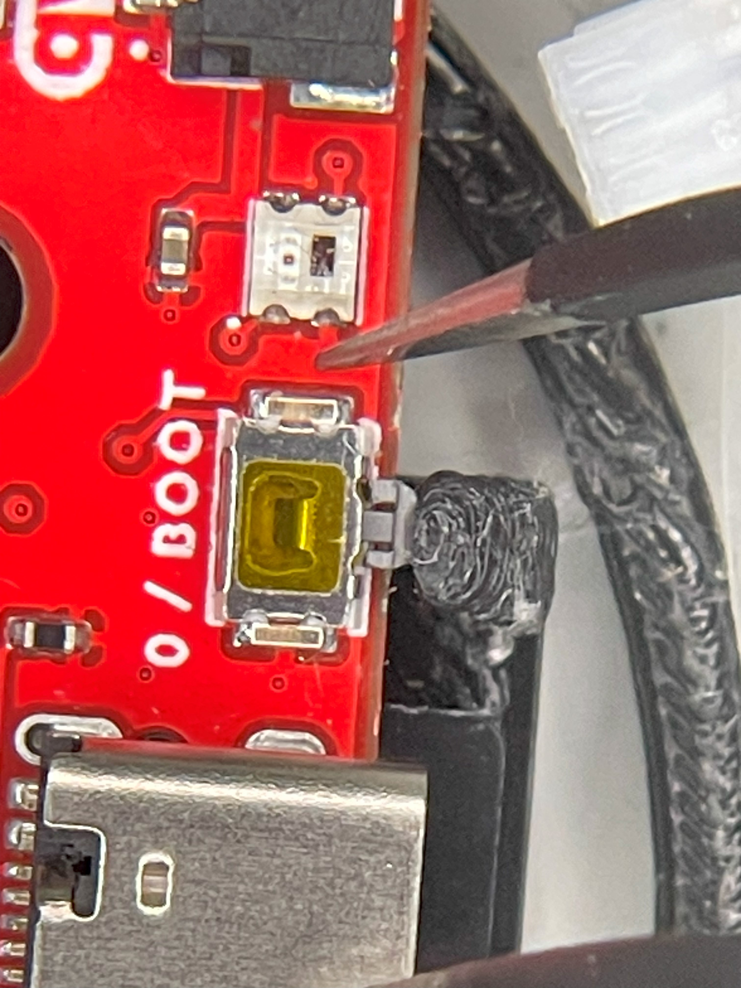

#### Appendix – SN: 2024032202– calibration

* [flatball-dev/lib/media/reports/f-dev-3.1.3-mmc5983ma_cal.pdf at main · misc-protolabs/flatball-dev (github.com)](https://github.com/misc-protolabs/flatball-dev/blob/main/lib/media/reports/f-dev-3.1.3-mmc5983ma_cal.pdf)

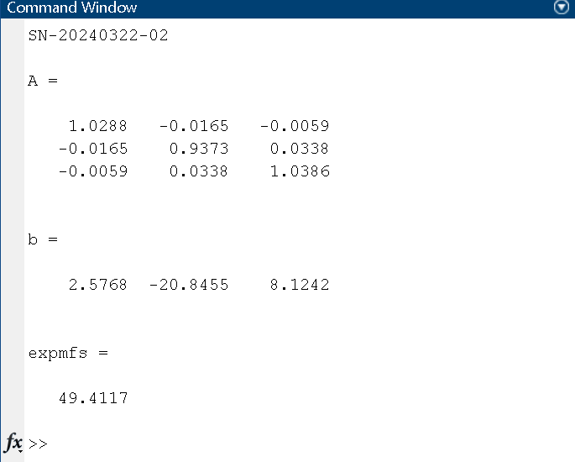

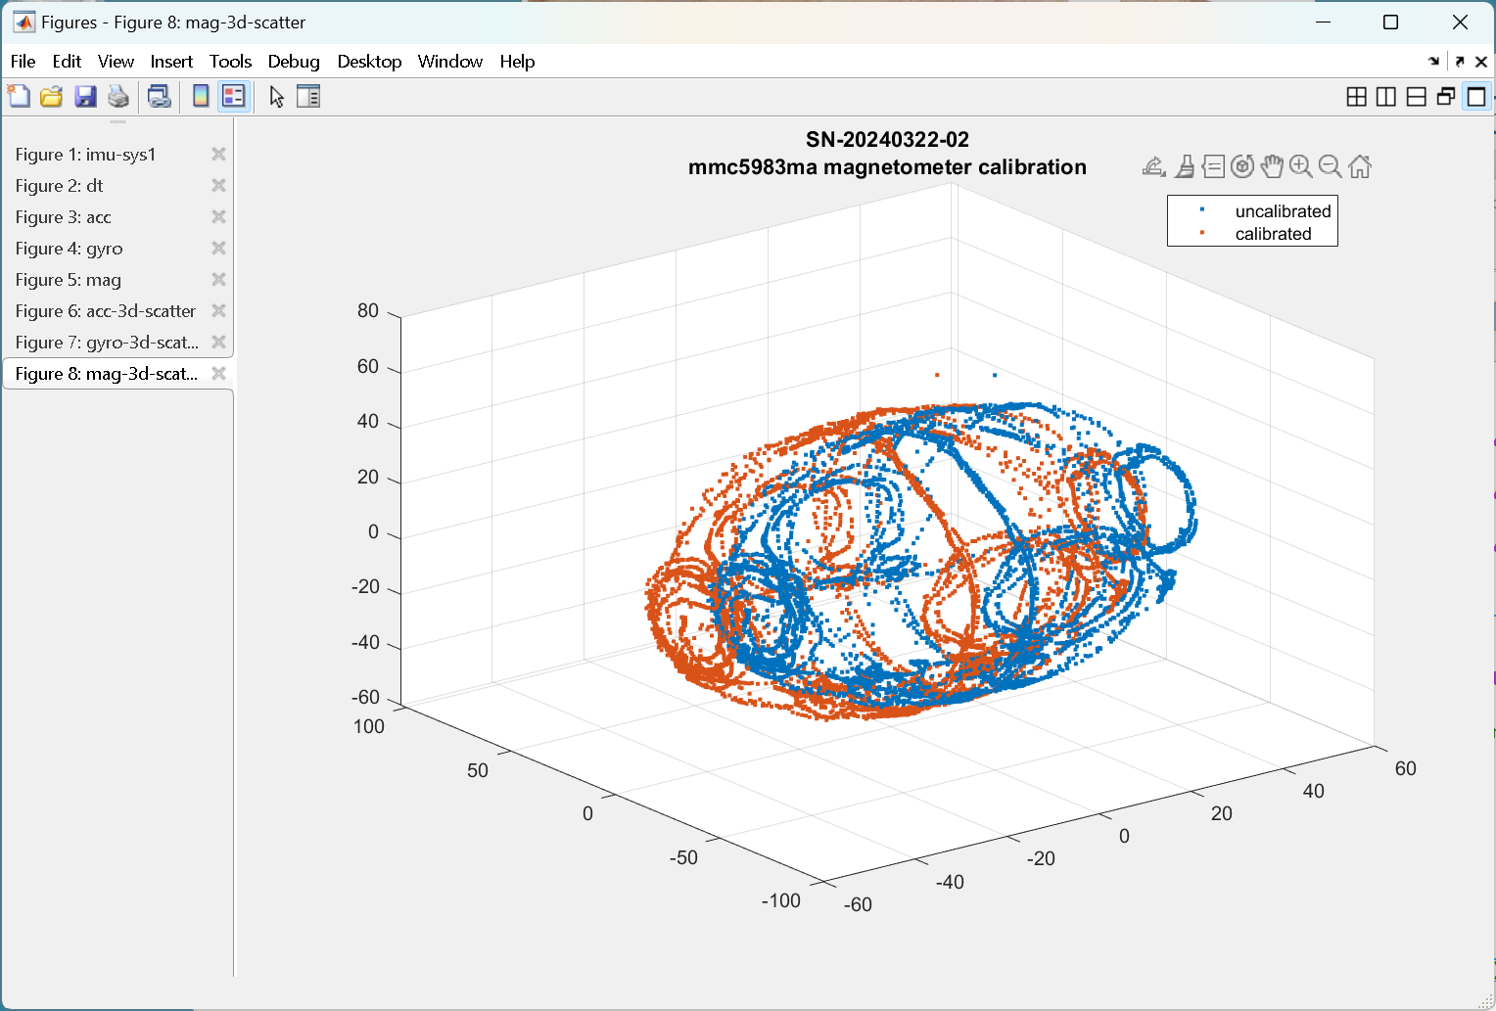

## SN:2024110603

#### SN:2024110603 – assembly

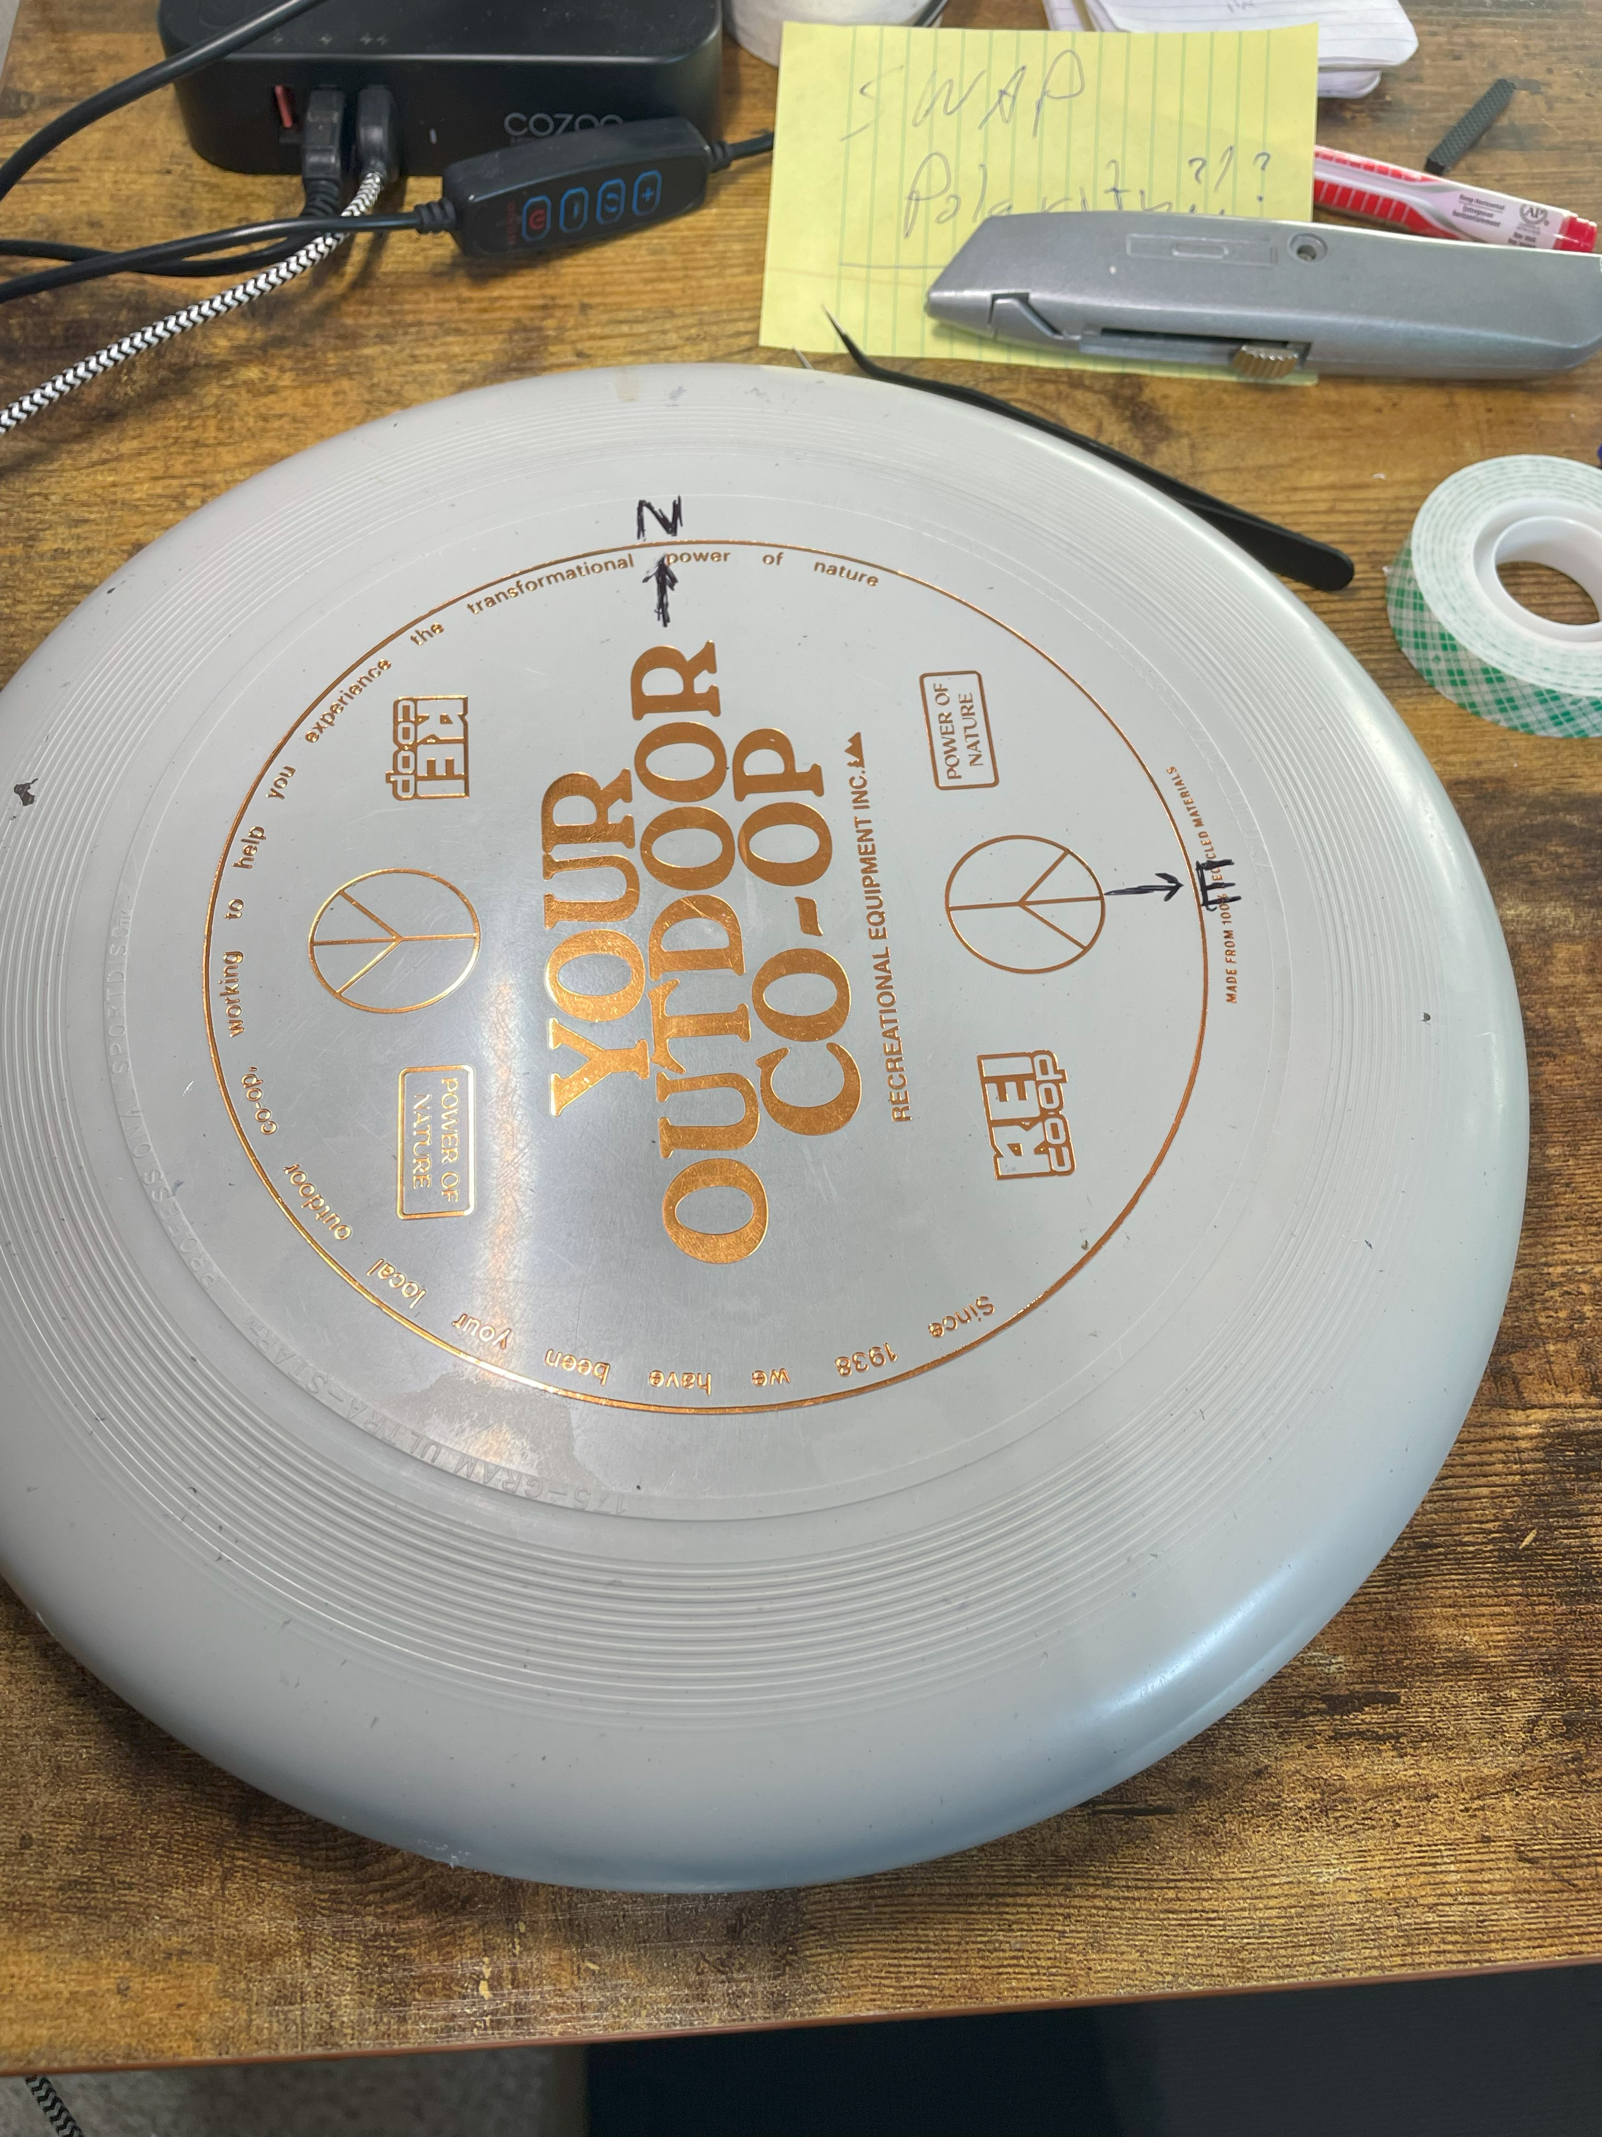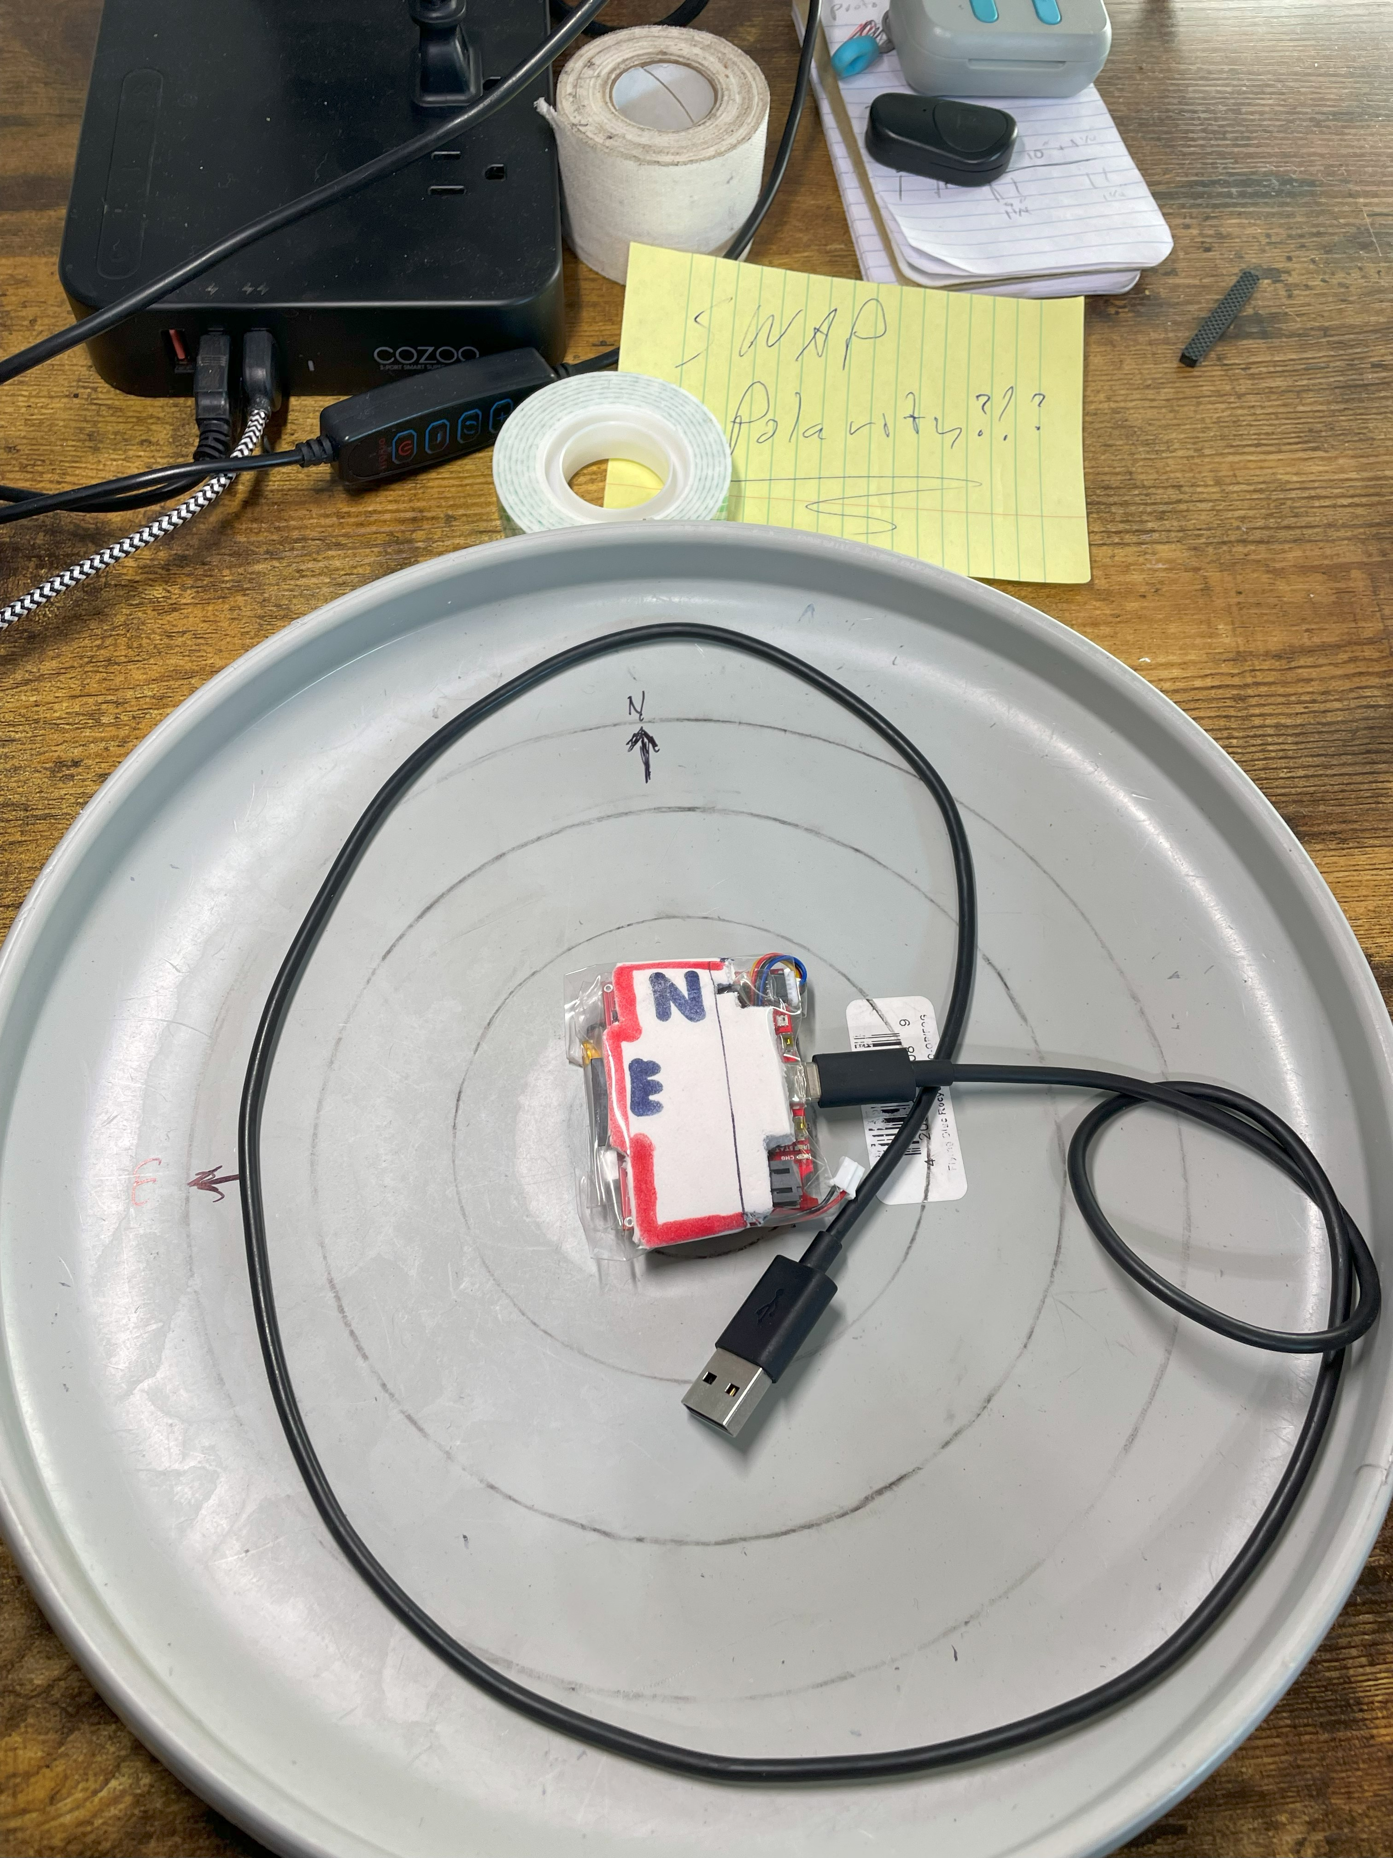

#### SN:2024110603 – calibration

